MOTHER MAJERI NURSERY SCHOOL

**END OF TERM II EXAMINATION, 2024**

**CLASS : TOP CLASS**

# SUBJECT : ENGLISH

**Name** :________________________________**stream**:_______

**1. Change the given letters to small letters.**

Q – q J __ F __



T __ N __ L __

**2. Name the pictures using; Here is …………………**

- Here is a _____________



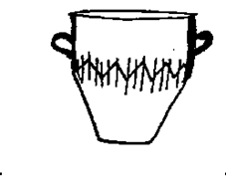

- _________________________________

[](https://www.google.com/url?q=http://wallpaperzoo.com/cartoon-flowers-coloring-pages-23849.html&sa=U&ei=0YU6U578OYfItQaJmoGIAQ&ved=0CEoQ9QEwDTiEAg&usg=AFQjCNFQ8y7h4oGlXwl1t46u3ooEybRxrw)

- _________________________________

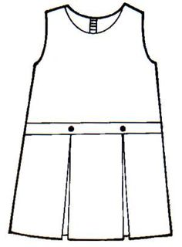

- _________________________________



* _________________________________

**3. Write the words in capital letters.**

jug – JUG

window - _______________ chair - _____________

fish - _____________ grass - _____________

room - _____________

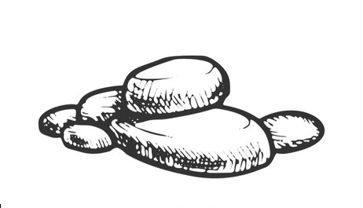**4. Complete the sentences.**

I can see a __________________.



I can see a _________________.

[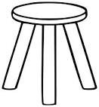](https://www.google.com/url?q=http://www.clker.com/clipart-three-legged-stool-outline.html&sa=U&ei=f9sWU9eDNeXI0wHemoHIBQ&ved=0CDAQ9QEwAA&usg=AFQjCNGLDymL8Kv25wYGlLw6rrdOS5BR2g)

I can see a _________________.

I can see a _________________.

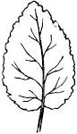

I can see a _________________.

**5. Use article “a” or “an”**

It is ____________arrow.

Here is __________ cat.

That is ___________ elephant.

This is ___________ spoon.

I can see ___________ apple.

**6. Give the plural form by adding (s).**

doll – dolls.

kettle - ______________

rat - _________________

pot - ________________

table - ______________

**7. Fill in the gaps with the correct word.**

A cow has ___________ legs.

I have _______________ toes.

A young one of a cat is ______________.

Every Sunday I go to _________________.

**END**